**Summary of Rules Relevant to Crossings**

1. All transactions need to be reported to ASX, including crossing, whether through CLOB or not.

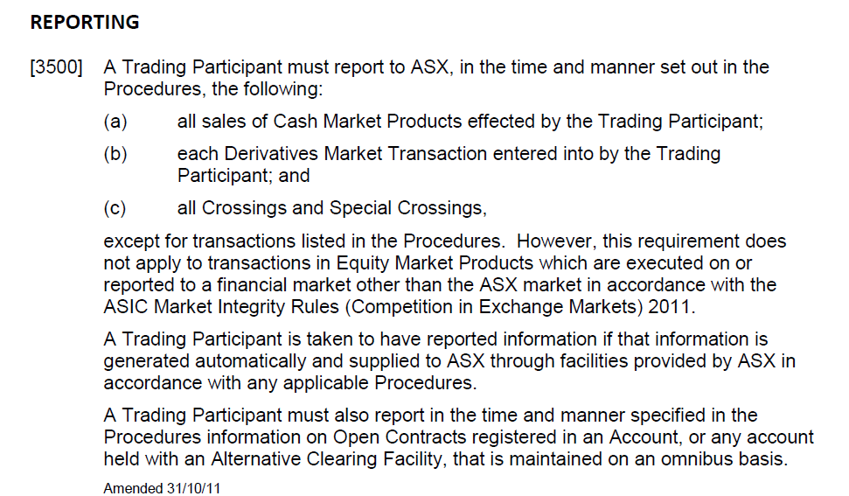

1. All transactions are required to be reported through ASX’s Trading Platform; hence they are 2 types of *recordtype* in the data, TRADE (through CLOB) and OFFTR (not through CLOB).

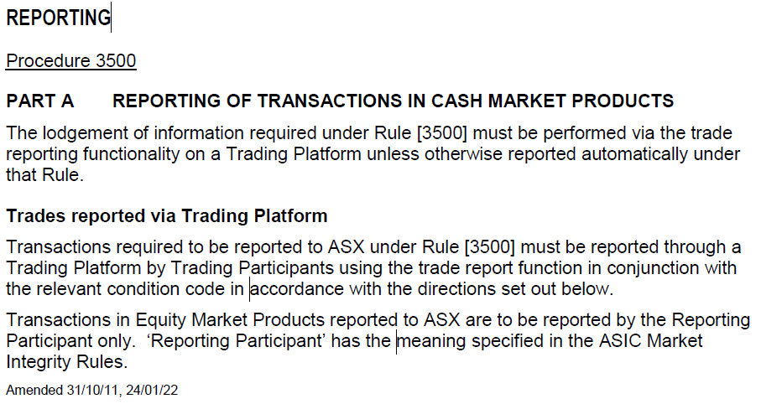

No change in content from 2011 version (only wording change).

1. Based on ASX websites, ASX offer off-market trades reporting facility, **only** for the following trade report types:
2. Trades with price improvement (NX code)
3. Block trades (S1, S2, S3)
4. Portfolio trades (SX)
5. Late and out-of-hours trades (L1, L2, L3, L4, L5)

These types of transactions will result as OFFTR in the data. Evidence:

* There are only 4 + 1 types of OFFTR XT on the data: “NX XT”, “S1/S2/S3 XT”, “SX XT”, and “L1/L2/L3/L4/L5 XT”. Plus “BP XT” (Booking Purposes) for administrative transactions.

All transactions must be entered into order book, by rule 6.1.1 ASIC market integrity rule, except 4 transactions above.

1. Trades on the CLOB will generate real time timestamps because of the system. How about crossing trades out of CLOB? Based on operating procedure, **trades with price improvements, block trades** (in open session),and **portfolio trades** (in open session and act as agent for both clients) need to be reported immediately to ASX. In the procedure, only **trades with price improvement** that is stated will be automatically generated.



No change in content for this procedure since 29/11/2010. However, at that time Procedure 4060 hasn’t had “trade with price improvement” until 23/11/2011 (“Crossings at or within the spread” introduced in ASIC and ASX rule). Meanwhile, priority crossing mechanism was discontinued on 26/05/2013, as market behaviour was leaning towards “trade with price improvement”.

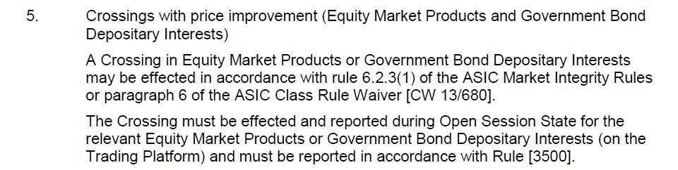



There is only wording change from 2011, the content is the same.

1. Supporting evidence: real time timestamp of **crossing with price improvement** through crossing system
2. CLSA crossing system

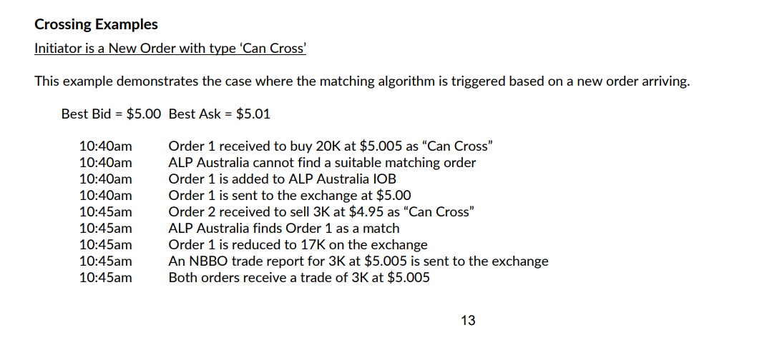

1. CommSec crossing system

**Appendix 1 - Definition**

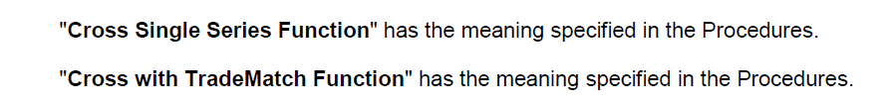





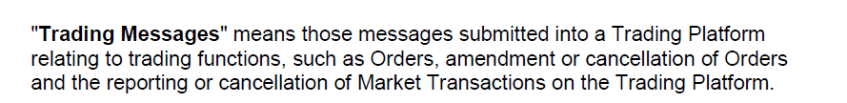

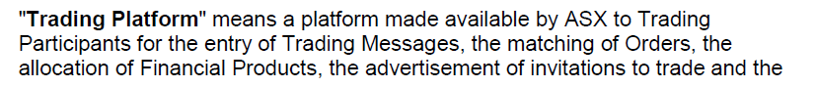

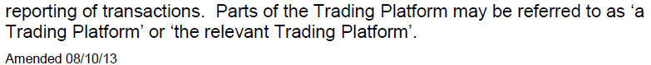



**Appendix 2 – Rules and Procedures**

1. Procedure 3500, ver 2011

1. Information Generated Automatically, amendment 2010

1. Trade with price improvement amendment 2011

